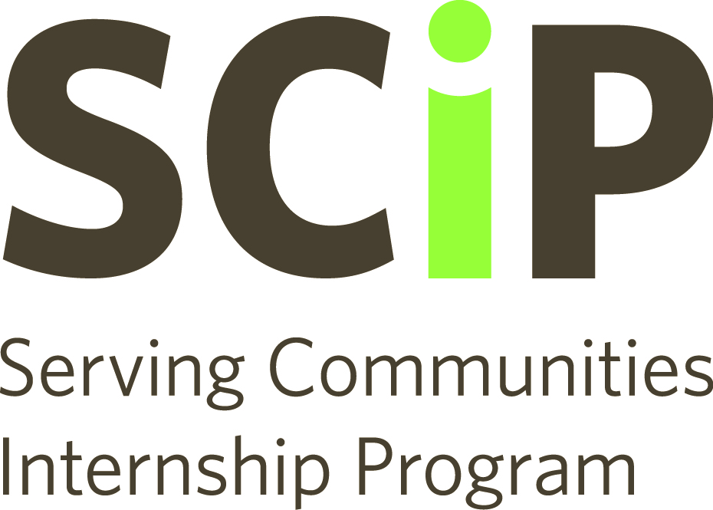

Internship Role Description Template

This is a template for you to use when creating your postings. We recommend you write your postings out using this template and save them on your computer before posting.

Description

Briefly describe the mission of your organization. This is not meant to be an exhaustive list of programs and services, but a few sentences telling potential interns what your organization is all about. In the last couple of sentences, link the position you are advertising to the mission of your organization.

It is important that your internship links to the mission of your organization. Not only will your internship be more attractive to potential interns, the work of the intern will more greatly benefit your organizations than a position based on busy-work.

Ideal for Someone with Coursework in:

- Ask for certain programs or coursework that relate to your internship instead of particular experience – the interns are still students, after all!
- Check out the resource section of the website for a list of programs we’ve put together to help you fill out this section. We’ve listed all programs at each of the 26 qualifying school for easy reference.
Some Special Skills Required

- Use plain English – avoid the use of jargon or sector language.
- If certain technical knowledge is required for your position, list that here. Be specific if necessary (ex: experience with WordPress required) or more general if you have the flexibility (ex: experience with Content Management Systems for websites required)

What We Will Accomplish at the End of the Internship

- List the tangible outputs you expect and list them out individually, the easier it is for the student to understand what is expected, the more likely they are to apply.
- It’s important to have a well thought out plan of what you’ll have your intern do, but here is not the place to list every detail.
- Instead, give students an idea of what they will be working towards – new website/marketing collateral/planned and completed event/volunteer handbooks/complied research to name a few – and who they could be working with – in a team/with the executive director/mostly independent.

Time Commitment:

Time commitment is no longer listed on the internship postings. Now, all postings indicate that the internships are part-time and exact time commitments are negotiated between the student and the intern. We have made this change to encourage students with the right skillsets and education to apply to your postings.

However, this doesn’t mean that time commitment shouldn’t be considered beforehand. We encourage you to have an idea of what you expect going into the internship. Remember, it is important to be flexible around the academic commitments of your intern.

The best time commitment is no time commitment. Timeline-based projects allow space for the intern to do the necessary amount of work, without watching the clock. If you chose to go this route, indicate to the student that there will be weekly/twice monthly/etc. progress meetings so the potential student knows that there will be support along the way.

If you chose to go the hourly route, indicate an hourly range that would be expected per week/month/etc., whether or not these hours would have to be completed during regular business hours or on their own time, and if they will have to come into the office or can work from home.

If there are any set-in-stone times or dates that the student would be required to be available, mention them here: board meetings/other meetings, events, etc.

1 short paragraph maximum

